Part 1
  - Purpose of the EEG-based RSVP login system is to create high security login method using brain activity. Three images are chosen as a password, and they are mixed with other images in RSVP. Then system checks user EEG whether it is responding to correct images.
  - Target stimuli are user’s chosen images. Non-target stimuli are the other symbols. In research paper’s setup 22 non-target and 3 target images are chosen.
  - It is Event Related Potential, because each measure of EEG is time-locked to some symbol. Moreover, it resembles P300-style oddball response, because target items are in stream of non-target items, and target symbols produce stronger positive ERP components.
  - According to paper, ERP have better intersubject reproducibility than oscillatory features. Some people cannot control signals related to oscillatory-feature system for reliable extend, and ERP is natural response of the brain, which can be replicated easily across subjects. Also, RSVP has shorter login time support, due to quick presentation of many stimuli.
  - Specific symbol is when chosen images themselves are chosen as target.
Categorical symbol is when whole set of images are chosen, like if elephant is chosen, then all images of elephants are target.
Part 2
- 500 Hz
- 32
- F7, F3, Fz, F4, F8, FC5, FC1, FC2, FC6, T7
- (32, 1513650), 48 436800
- Electrode layout seems reasonable based on the channel names and follows 10-20 EEG naming system. No misplacement is visible.
- PSD follows 1/f pattern, where lower frequency show higher power and power decreases as frequency increases. There is strong notch around 60 Hz, which probably reflect line-noise removal or suppression of electrical interference. Continues will 250 Hz, reflecting sampling rate of 500 Hz.
Results
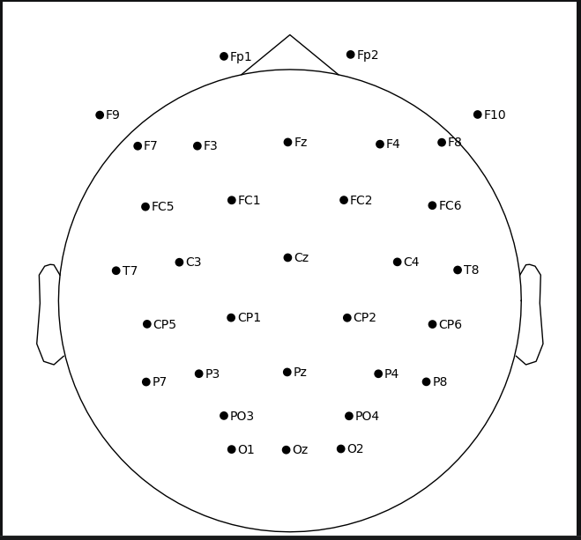
Figure 1: sensor layout
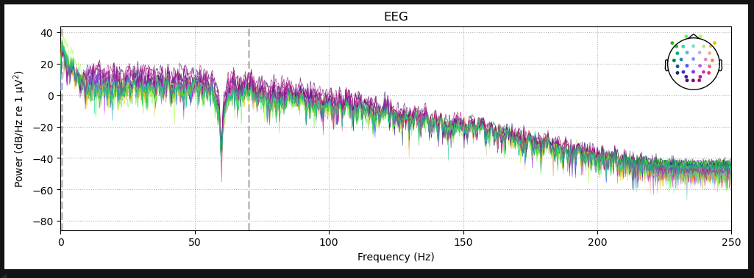
Figure 2: PSD

Part 3
3.3 Before preprocessing PSD spans to 250 Hz, follows 1/f pattern and shows notch at 60 Hz. 40 Hz low-pass filter suppresses higher frequency activity, and 100 Hz sampling rate limits PSD to 50 Hz.
3.4 Preprocessing focuses on analyzing low frequency, because ERP components are usually time-locked below 40 Hz. Filter reduces noise of higher frequency preserving ERP waveform. And lowering sampling rate to 100 Hz is for showing ERP focused frequency. Moreover, tmax is set to 10 s, which means that time window we are focusing on is 0-10 s, and power spectrum is computed in this time window. Both preprocessing parts make data smaller, cleaner and more efficient for our scenario.
3.5 It only relies on low-pass filtering and down-sampling, while ignoring artifact correction or bad-channel removal. In our experiment scenario, these artifacts can add up to time-locked responses and reduce quality of ERP analysis.
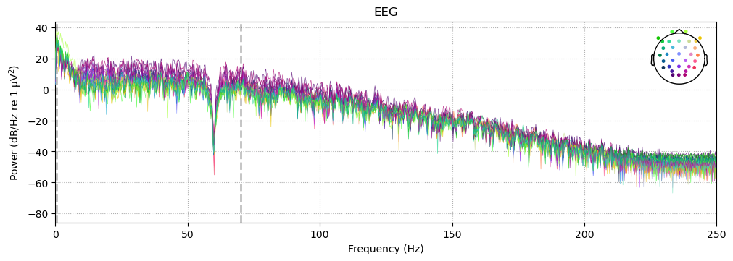
Figure 3: Before Preprocessing
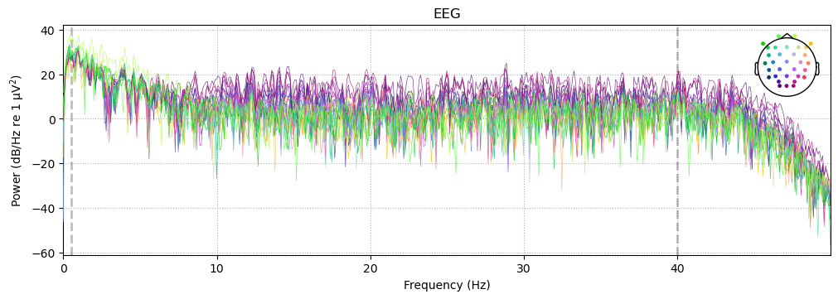
Figure 4: After Preprocessing

Part 4
4.7 452 targets and 3298 non-targets
4.8 There are more NT than T, because target is rare stimuli on which brain response more distinctive making it easy to detect. This is main logic we will use for later analysis.
<Epochs | 3750 events (all good), -0.2 – 1 s (baseline -0.2 – 0 s), ~110.8 MiB, data loaded,
'T': 452
'NT': 3298>
<Epochs | 452 events (all good), -0.2 – 1 s (baseline -0.2 – 0 s), ~13.4 MiB, data loaded,
'T': 452> <Epochs | 3298 events (all good), -0.2 – 1 s (baseline -0.2 – 0 s), ~97.5 MiB, data loaded,
'NT': 3298>
Part 5
5.3 Target trials have stronger positive deflection than non-target trials in the P300 range.
5.6 320 – 430 ms and 620 – 650 ms
5.7 The observed effect is consistent with a plausible P300-like response because the target condition shows a stronger centro-parietal positivity.
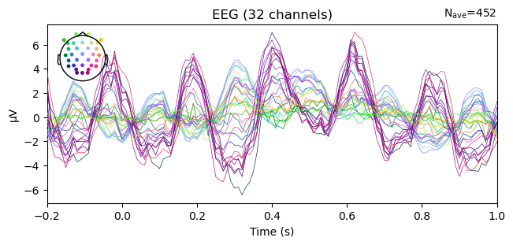
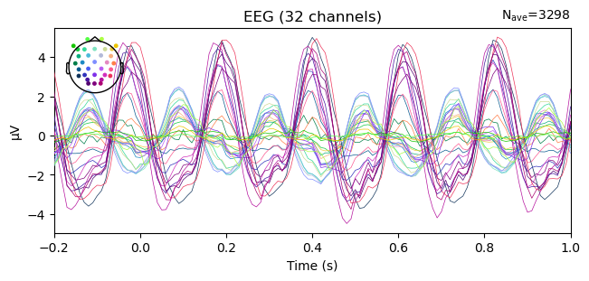
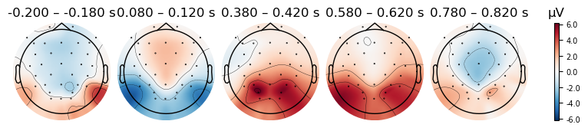
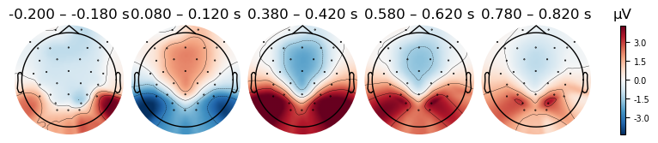
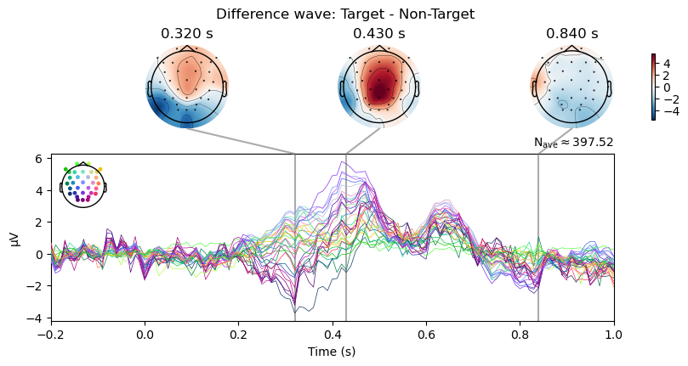

Part 6
6.1 A centro-parietal ROI was defined using the available channels Cz, Pz, CP1, CP2, P3, and P4, restricted to those present in the dataset.
6.2 The mean amplitude for target and non-target trials was computed in the 300–600 ms window.
6.3 The target minus non-target amplitude difference was 2.26 µV.
6.4 The target peak amplitude was 4.07 µV at 400.0 ms, while the non-target peak amplitude was 0.76 µV at 600.0 ms.
6.5 The ROI and time window were chosen because the P300 is typically strongest over centro-parietal electrodes around 300–600 ms, and this matched the visual ERP results.
6.6 The quantitative results do support the visual ERP observations because the target response was larger than the non-target response in the selected ROI and time window.
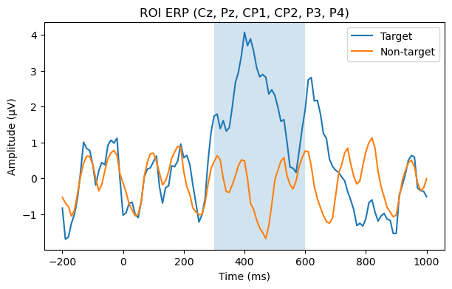

Part 7
7.1 Bipolar ocular channels were created as F9−F10 for HEOG and EOGv1−Fp2 for VEOG.
7.2 Visual inspection showed that VEOG contained blink-like transients, while HEOG appeared noisier.
7.3 Epochs were marked as contaminated when VEOG peak-to-peak amplitude exceeded 150 µV.
7.4 Contaminated epochs were removed from the existing epoch set.
7.5 Target and non-target ERPs were recomputed after artifact rejection.
7.6 The cleaned and uncleaned results were compared using ROI amplitudes in the 300–600 ms window.
7.7 Artifact rejection slightly strengthened the P300 effect because the target amplitude increased and the target–non-target difference became larger after cleaning.
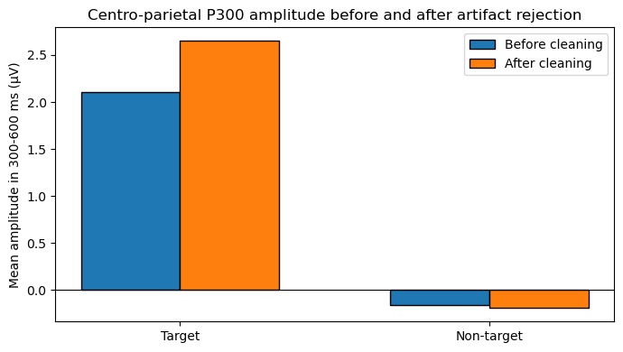
Part 8
8.3
Each epoch is represented as a flattened channel × time matrix within the P300-relevant window (200–600 ms post-stimulus). The design choices are:
Time window (200–600 ms): Captures early and late P300 components, avoiding pre-stimulus noise.
Channels (All scalp EEG, excluding Fp1, Fp2, F9, F10): P300 is broad, and excluding too many channels risks losing valuable information.
Representation (Flattened channel × time vector): Retains both temporal and spatial features.
Amplitude unit (µV): Converts raw MNE volts for numerical stability.
Averaging over fixed channels loses spatial information. Flattening allows the classifier to identify key channels and time points. The dimensionality issue (n_features >> n_epochs) is addressed using shrinkage LDA in Part 9, which regularizes the covariance estimate. To prevent data leakage, the StandardScaler is re-fitted inside each cross-validation fold in Part 9.

Part 9
9.6 In classic RSVP targets are flashed 10% of the time. If regular ‘lazy ’classifier will learn to predict 0 always, then it will get 90% accuracy. Thus, we must use Balanced Accuracy and ROC accuracy.
9.7 Classifier shows solid single-trial RSVP performance. Its ROC AUC of 0.7948 indicates good separability between Target and Non-Target epochs, while the Balanced Accuracy of 0.7133 confirms above-chance performance on both classes despite class imbalance. From the confusion matrix, it detects 270/452 Targets (59.7%) and 2735/3298 Non-Targets (82.9%), which is a reasonable tradeoff for noisy single-trial P300 data.
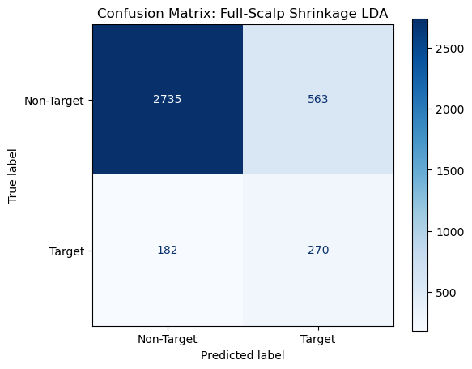
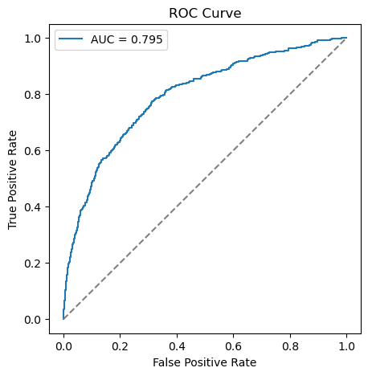
Part 10
10.5 Averaging across more and more sequences mathematically cancels out zero-mean EEG noise while amplifying the time-locked P300 signal, pushing the theoretical AUC toward a perfect 1.0.
However, every single repetition physically adds raw seconds to the time it takes the user to select just one image. System engineers must empirically find the absolute minimum number of sequences required to cross a safe threshold (e.g., 90% accuracy). Pausing at exactly that threshold maximizes the ITR.
Base Single-Trial AUC (1 Rep): 0.790
Aggregated AUC (5 Reps): 0.963
Aggregated AUC (15 Reps): 0.999
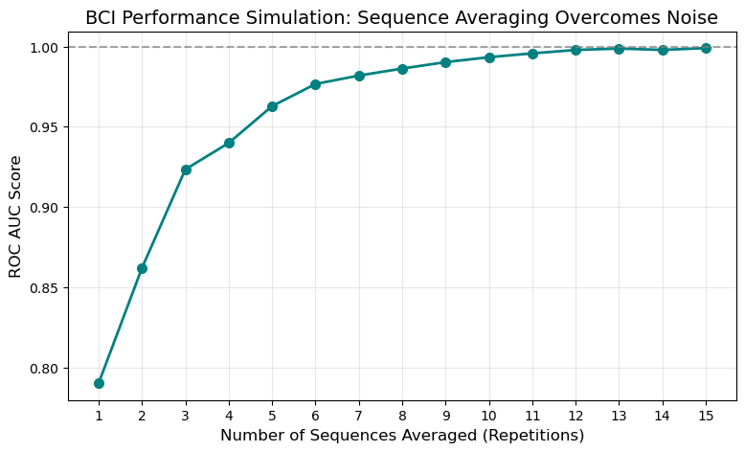

Part 11 Critical Reflection
11.1 The pipeline is highly interpretable, lightweight, and mathematically robust. It uses standard, proven MNE-Python routines for preprocessing and leverages a transparent spatial-temporal feature extraction. By employing Shrinkage LDA, the pipeline avoids extreme overfitting on highly correlated EEG data, which is critical for datasets with a small number of trials.
11.2 The pipeline uses incredibly crude static thresholding (>150 µV) for artifact rejection. This throws away perfectly good P300 data simply because a blink occurred randomly in the background. Furthermore, the preprocessing lacks an explicit high-pass filter (e.g., 0.1 Hz), leaving low-frequency drifts inside the epochs. Lastly, the feature design relies purely on temporal amplitudes rather than exploiting advanced spatial filtering techniques.
11.3 The paper describes a full "High-Security EEG-Based Login System". The notebook completely isolates the offline binary classification step. We do not model the logical translation of these P300 stimuli into actual password/PIN tokens. We also lack the online/real-time processing architecture, user feedback UI, and dynamical stopping criteria (halting the RSVP flashes instantly once authentication confidence is reached).
11.4 The paper relies on dry electrodes, which are notoriously sensitive to impedance fluctuations. In a real-world setting, the user moving around, jaw clenching, sweating, or the headset physically shifting on the scalp will catastrophically degrade the Signal-to-Noise Ratio. Additionally, "BCI Illiteracy" or simple user fatigue/distraction over a long session will physically dampen the amplitude of the P300 response.
11.5 Instead of throwing away an entire epoch because of a single blink, decompose the EEG signal using ICA, specifically target the topomap corresponding to the blink (e.g., frontal poles), mathematically subtract it, and reconstruct the clean EEG epoch.
Abandon flat temporal vectors and encode the EEG data using covariance matrices enhanced with spatial filters like xDAWN. Classifying xDAWN Covariances on a Tangent Space using Logistic Regression is the modern proven state-of-the-art for P300 BCI pipelines, and will maximize cross-subject accuracy.

